

Electronics Engineering Students’ Association (ELESA)

Presents

ELECTROVERT 2018

The Performers’ creed

Name of the Event: **Circuit-Tech (Expert )**

Candidate’s Code:

**Instructions**

* All **30 questions** are compulsory.
* All questions are compulsory and carries equal amount of marks.
* Use of calculators is allowed.
* Use of mobile is strictly prohibited.

Date: **08 Sept 2018**

Time: **30 min**

1. A good current buffer has

(A) low input impedance and low output impedance

(B) low input impedance and high output impedance

(C) high input impedance and low output impedance

(D) high input impedance and high output impedance

2. The term LASER stands for

a) Light amplification by simulated emission of radiation

b) Light and simulated emission of radiation

c) Light amplification simulate emitted of radiate

d) Light amplifier by system emitted of radiation.

3.  Which of the following is true?  
a) CC amplifier has a large current gain  
b) CE amplifier has a large current gain  
c) CB amplifier has low voltage gain  
d) CC amplifier has low current gain

4. In the low-pass filter shown in the figure, for a cut-off frequency of 5 kHz, the value of R2 (in kohm) is _____ . R

5. The figure shown 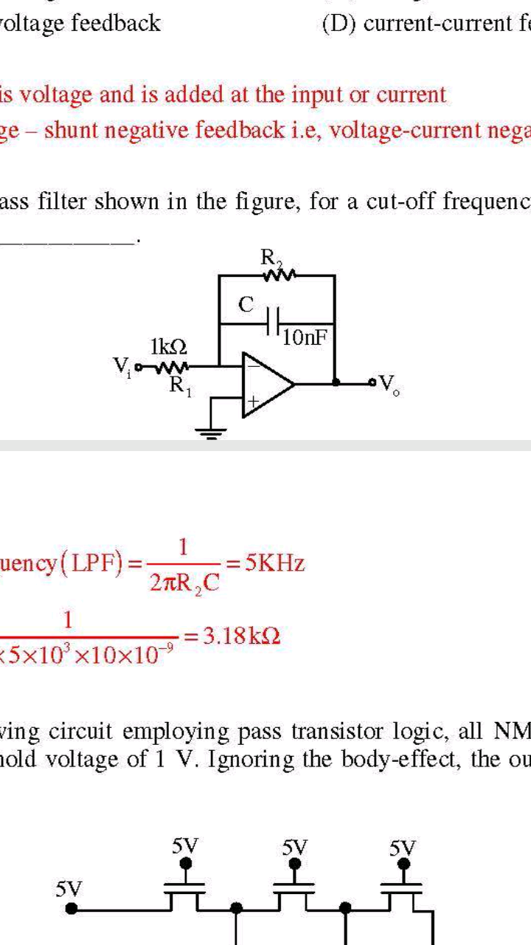

a)3.18

b)2.8

c) 10

d)4

5. Consider the feedback system shown in the figure. The Nyquist plot of G(s) is also shown. Which one of the following conclusions is correct?

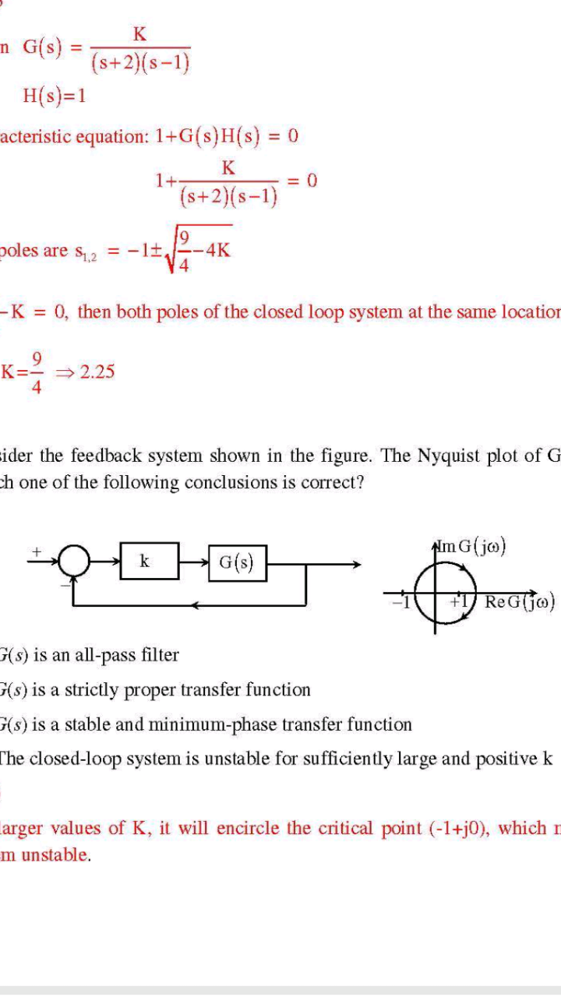(A) G(s) is an all-pass filter

(B) G(s) is a strictly proper transfer function

(C) G(s) is a stable and minimum-phase transfer function

(D) The closed-loop system is unstable for sufficiently large and positive k

6. A good trans-impedance amplifier has

(A) low input impedance and high output impedance.

(B) high input impedance and high output impedance.

(C) high input impedance and low output impedance.

(D) low input impedance and low output impedance.

7. By Thevenin’s theorem find Vth and Rth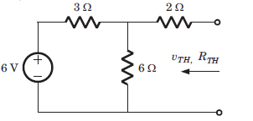

a) 3V, 4Ω

b) 4V, 4Ω

c) 8V, 6Ω

d) 6V, 6Ω

8. Find the transfer function of the circuit shown below

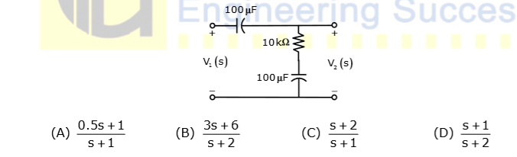

9. In the circuit shown below the op-amps are ideal. The out V in Volts is

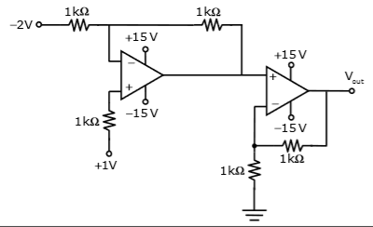

(A) 4 (B) 6

(C) 8 (D) 10

10. The voltage gain of the amplifier is 8 and the current gain is 7. The power gain of the amplifier is  
a) 56 db  
b) 17.481 db  
c) 34.963 db  
d) 1 db

11. In the circuit shown below what is the output voltage ( ) out V if a silicon transistor Q and an ideal op-amp are used?

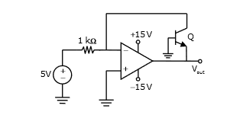

(A) –15V (B) –0.7V

(C) +0.7V (D) +15V

12. Which of the factors doesn’t change the diode current.  
a) Temperature  
b) External voltage applied to the diode  
c) Boltzmann‘s constant  
d) Resistance

13. Find i1?

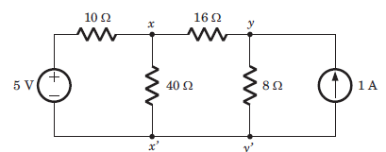

a) 3 A b) 0.75 mA c) 2 mA d) 1.75 mA

10. Which of the factors doesn’t change the diode current.  
a) Temperature  
b) External voltage applied to the diode  
c) Boltzmann‘s constant  
d) Resistance

14. For the following system

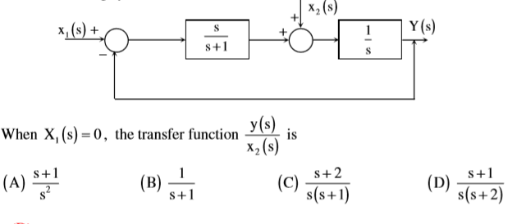

15.In the differential amplifier shown in the figure, the magnitudes of the common-mode and differential-mode gains are Acm and Ad, respectively. If the resistance RE is increased, then

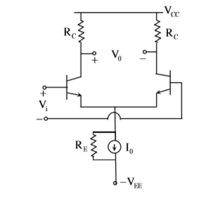

(A) Acm increases

(B) common-mode rejection ratio increases

(C) Ad increases

(D) common-mode rejection ratio decreases

16. To control fan speed and intensity control of bulb which device is used..

a)SCR

b)TRIAC-DIAC

c) BJT

d)DIODE

17. With Gate open, maximum anode current at which SCR is turned off from ON codition is called

a) Breakdown voltage

b) Peak reverse voltage

c) Holding current

d) Lathing Current

18. Bidirectional semiconductor device is

a) Diode

b) BJT

C) SCR

D) TRIAC

19. For an n-variable Boolean function, the maximum number of prime implicants is

(a) 2(n-1) (b) n/2

(c) 2n (d)

20. In a uniformly doped BJT, assume that *NE*,*NB* and *NC* are the emitter, base and collector doping in atoms/cm3, respectively. If the emitter injection efficiency of the BJT is close unity, which one of the following condition is TRUE ?

(A) *NE* = *NB* = *NC*

(B) *NE* >> *NB* and *NB* > *NC*

(C) *NE* = *NB* and *NB* < *NC*

(D) *NE* < *NB* < *NC*

21. Assuming the OP-AMP to be ideal, the voltage gain of the amplifier shown below i

(a) -R2/R1

(b) -R3/R1

(c) (*R*2 || *R*3 )/R1

(d) −|*R*2 + *R*3 l /R1

# 

22.The action of JFET in its equivalent circuit can best be represented as a______.

(a)Current controlled current source

(b)Current controlled voltage source

(c)Voltage controlled voltage source

(d)Voltage controlled current source

23. The present output *Q n* of an edge triggered *JK* flip-flop is logic 0. If *J* = 1, then

*Qn* + 1

(A) Cannot be determined (B) Will be logic 0

(C) will be logic 1 (D) will rave around

24. Find the correct match between group A and group B

A B

E- varactor diode 1.Voltagereference

F-Pin diode 2.high frequency switch

G- Zener diode 3.tuned switch

H- Schottky diode 4.current controlled attenuator

1. E-4 E-2 G-1 H-3
2. E-3 E-4 G-1 H-2
3. E-2 E-4 G-1 H-3
4. E-1 E-3 G-2 H-4

25. For the Op-Amp circuit shown in the figure, *V*0

(A) -2 V (B) -1 V

(C) -0.5 V (D) 0.5 V

26. The following binary values were applied to the *X* and *Y* inputs of NAND latch shown in the figure in the sequence indicated below :

*X* = 0,*Y* = 1;*X* = 0, *Y* = 0; *X* = 1; *Y* = 1

The corresponding stable *P Q*, output will be.

1. *P* = 1,*Q* = 0; *P* = 1,*Q* = 0; *P* = 1,*Q* = 0 or *P* = 0,*Q* = 1
2. *P* = 1,*Q* = 0; *P* = 0,*Q* = 1; or *P* = 0,*Q* = 1; *P* = 0,*Q* = 1
3. *P* = 1,*Q* = 0; *P* = 1,*Q* = 1; *P* = 1,*Q* = 0 or *P* = 0,*Q* = 1
4. *P* = 1,*Q* = 0; *P* = 1,*Q* = 1; *P* = 1,*Q* = 1

27. A Hilbert transform is a

(A) non-linear system (B) non-causal system

(C) time-varying system (D) low-pass system

28. Which of the following is true?

(a)A silicon wafer heavily doped with boron is a *p*+ substrate

(b)A silicon wafer lightly doped with boron is a *p*+ substrate

(c)A silicon wafer heavily doped with arsenic is a *p*+ substrate

(d)A silicon wafer lightly doped with arsenic is a *p*+ substrate

29. The figure shown represent:

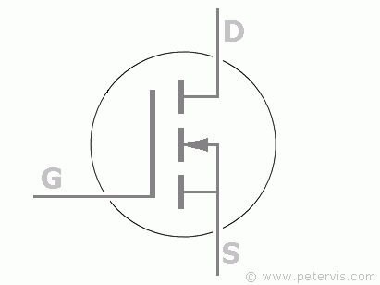

(a) n-channel MOSFET

(b) Enhanced-mode E-MOSFET

(c) p-Channel MOSFET

(d) J-FET

30. The number of bytes required to represent the decimal number1856357 in packed BCD form is___.

(a)8 bytes (b)4 bytes

(c)2 bytes (d)6 bytes